Title of Paper (Times New Roman 13 pt.; Capitalize the first letter of each word)
(1 Enter, 11 points)
First Author^{1*}, Co-Author² (First name Second Name, 11 pt.)
(1 Enter, 11 points)
¹Faculty of Abc, XXXXX University (11 pt.)
²Faculty of Abc, XXXXX University (11 pt.)
*Corresponding author, E-mail: sample@psu.ac.th (9 pt.)
(1 Enter, 11 points)
Abstract (Times, bold, 11 pt.)
Press one tab on the left for each indent; Start with Times New Roman sized 11 pt.; No more 300 words used, consisting of the statement of the problem/objectives/questions, research methods, results, and implications and/or recommendations……………………………………………………..
…………………………………………………………………………………………………………………………………………………………………………………………………………………………………………………………………………………………………………………………………………………………………………………………………………………………………………………………………………………………………………………………………………………………………
(1 Enter, 11 points)
Keywords (Times, bold, 11 pt.) : aaaa, bbbb, cccc. dddd (3-5 keywords; Press a space bar between each keyword)
(1 Enter, 11 points)
Introduction (bold, 11 pt)
(Time 11 pt.) Press one tab on the left for each indent; State the background and significance of the problem ………………………………………….………………………………………………..
……………………………….………………………………………………………………………...……………….…..………………………….…………………………………………………………………………….…..………………………….…………………………………………………………………………….…..………………………….…………………………………………………………………………….…..………………………….…………………………………………………………………………………………..….……………………………………………………………………………
(1 Enter, 11 points)
Research Objective (s)/ Research Questions (bold, 11 pt.)
(Time 11 pt.) Press one tab on the left for each indent; State the objectives/hypotheses of the study.........................................................………………………………………… ……………………………….…………………………………………………………...……………………………………………….………………………………………………………………...……………………………………………………………………………………………………………………………………………………………………………………………………………………………..…….
(1 Enter, 11 points)
Literature Review (bold, 11 pt.)
(Time 11 pt.) Press one tab on the left for each indent; Provide the overview of major writings and other sources on a selected topic/topic relevant to your study……………………………………….. ……………………………….…………………………………………………………...……………………………………………….…………………………………………………………...……………………………………………….…………………………………………………………...………………
(1 Enter, 11 points)
Methodology (bold, 11 pt.)
(Time 11 pt.) Press one tab on the left for each indent; Describe research design, samples/participants, data collection methods, and data analysis. ……………………………………… ……………………………….…………………………………………………………………...…………………………………………….………………………………………………………………...…………………………………….…………………………………………………………………...…………………………………………….………………………………………………………………...…………………………………….…………………………………………………………………...…………………………………………….………………………………………………………………...………………………………………………………………………………………………………………… (1 Enter, 11 points)
Results (bold, 11 pt.)
(Time 11 pt.) Press one tab on the left for each indent; Report the results according to the objectives/research questions. You may use tables with explanations and interpretations of significant data. ……………………………………………………………………………………………………...
……………………………….…………………………………………………………………...…………………………………………….………………………………………………………………...………………………………………………………………………………………………………………… (1 Enter, 11 points)
Table 1: Table name (11 pt.)

Source: (if available) (9 pt.)
(1 Enter, 11 points)
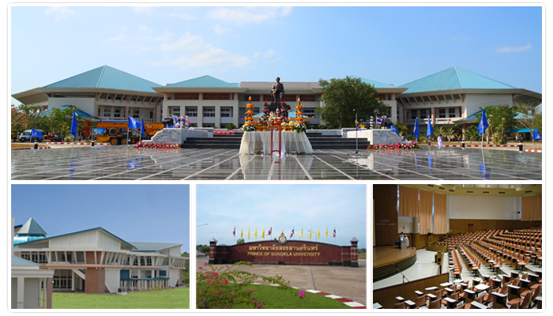
Picture 1: Picture/ Graph title (11 pt.)
Source: (if available) (9 pt.)
(1 Enter, 11 points)
Discussion / Findings and Discussion (bold, 11 pt.)
(Time 11 pt.) Summarize key the findings; link the discussion with the objectives/research questions; Note that this section may be combined with Findings, Findings and Discussion……… ……………………………….…………………………………………………………………...…………………………………………….………………………………………………………………...………………………………………………………………………………………………………………… (1 Enter, 11 points)
Conclusion (bold, 11 pt.)
(Time 11 pt.) State your conclusions in clear, simple language. Do not reiterate your results or discussions. Indicate recommendation for future applications or opportunities for future research.
……………………………….…………………………………………………………………...…………………………………………….………………………………………………………………...…… ……………………………….…………………………………………………………………...…………………………………………….………………………………………………………………...…… (1 Enter, 11 points)
References (bold, 11 pt.)
Start typing ALL and ONLY the references cited in the text, using the APA 7th edition referencing style, using the following format:

.......................................................................................................................................................................................................................................................................................................................
.......................................................................................................................................................................................................................................................................................................
.......................................................................................................................................................................................................................................................................................................

