Title of Paper (Times New Roman 13 pt.; Capitalize the first letter of each word)
(1 Enter, 11 points)
First Author^{1*}, Co-Author² (First name Second Name 11 pt.)
(1 Enter, 11 points)
¹Faculty of Abc, XXXXX University (11 pt.)
²Faculty of Abc, XXXXX University (11 pt.)
*Corresponding author, E-mail: sample@psu.ac.th (9 pt.)
(1 Enter, 11 points)
Abstract (Times, bold, 11 pt.)
Press one tab on the left for each indent; Start with Times New Roman 11 pt.; No more 300 words used; ……………………………...………………………………………...……………………..
…………………………………………………………………………………………………………………………………………………………………………………………………………………………………………………………………………………………………………………………………………………………………………………………………………………………………………………………………………………………………………………………………………………………………
(1 Enter, 11 points)
Keywords (Times, bold, 11 pt.) : aaaa, bbbb, cccc. dddd (3-5 keywords; Press a space bar between each keyword)
(1 Enter, 11 points)
Introduction (bold, 11 pt)
(Time 11 pt.) Press one tab on the left for each indent; State the background and significance of the problem ………………………………………….………………………………………………..
……………………………….………………………………………………………………...…………………………………………………………………………………………………………………………………………………………………………………………………………………………………………………………………………...…….
……………………………….………………………………………………………………...……………………………………………………………………………………………………………………………………………………………………………………………………………………………………………………………………………………………………………………………………… …………………………………………………………………………………………………………… …………………………………………………………………………………………………………… (1 Enter, 11 points)
Content
(Time 11 pt.) Press one tab on the left for each indent; State the objectives/hypotheses of the study;.........................................................………………………………………… ……………………………….…………………………………………………………...……………………………………………….………………………………………………………………...………………………………………………………………………………………………………………………
……………………………….………………………………………………………………...…………………………………………………………………………………………………………………………………………………………………………………………………………………………………………………………………………………………………………………………………………………………………………………………………………………………………………………… (1 Enter, 11 points)
Table 1: Table name (11 pt.)
Source: (if available) (9 pt.)
(1 Enter, 11 points)
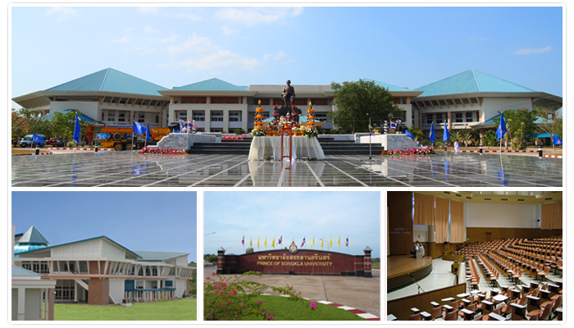
Picture 1: Picture/ Graph title (11 pt.)
Source: (if available) (9 pt.)
(1 Enter, 11 points)
Conclusion (bold, 11 pt.)
(Time 11 pt.) State your conclusions in clear, simple language; include suggestions for future applications or opportunities for future research……………………………………………………..….
……………………………….…………………………………………………………………...…………………………………………….………………………………………………………………...…… ……………………………….…………………………………………………………………...…………………………………………….………………………………………………………………...…… (1 Enter, 11 points)
References (bold, 11 pt.)
Start typing ALL and ONLY the references cited in the text, using the APA 7th edition referencing style, using the following format:

.......................................................................................................................................................................................................................................................................................................................
.......................................................................................................................................................................................................................................................................................................
.......................................................................................................................................................................................................................................................................................................

